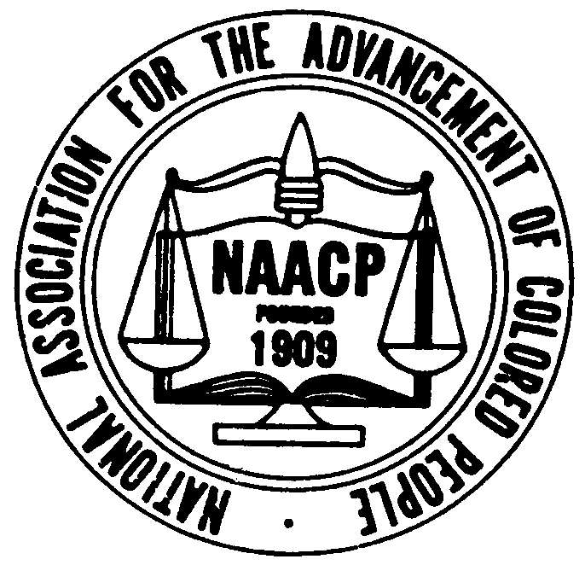 |  | Johnson County NAACP #4038  (913) 362-2272 phone  (913) 362-2273 fax  Email: NEJCNAACP@SBCGLOBAL.NET  Website: WWW.JCNAACP.ORG | Mailing Address:  PO Box 2622  Shawnee Mission, KS 66201  Street Address:  9948 W. 87th Street, Ste. A1  Overland Park, KS 66212
President  Jay Holbert  1st Vice President  Elisha Williams  2nd Vice President  Victoria Haynes  Secretary  Vacant  Assistant Secretary  Joarvonia George  Treasurer  Leneer Barber  Assistant Treasurer  Shirley Taylor  Parliamentarian  Wanda Vaughn  Executive Members  Rebecca Barber  Robin Barber  Destiny Costley  Gordon Criswell  Jenelle Holmes  Darnell Hunt  Marva Johnson  Valerie Johnson  Chris Kostelac  Gloria Snowden  JenniferTanquary  Standing Committees  ACT-SO  Community Coordination  Economic Development  Education  Finance  Freedom Fund  Health  Legal Redress  Membership  Political Action  Press & Publicity  Religious Affairs  Special Task Force  WIN  Youth Work  Housing  Legal Redress  Membership  Political Action  Religious Affairs  Youth Work | January 8, 2022  Mission Statement  The mission of the NAACP is to ensure the political, educational, social, and economic  Equality of rights of all persons and eliminate race-based discrimination.  General Meeting (Zoom)  Call to Order  Opening Prayer  Agenda approval  Minutes from last meeting  Treasurer report  Committee reports  Old Business  New Business  Adjourned  Vision Statement  The vision of the NAACP is to ensure a society in which all individuals  have equal rights without discrimination based on race.

